1. **Detail of the data set**

* Name: owid-energy-data
* Source: Our World in Data

<https://ourworldindata.org/energy>

The data set is information on energy sources used, data on energy use by countries, information on population and GDP. We will create charts to analyze the relationship between the fields, from which to draw some conclusions about the energy use situation and some predictions.

For the POWER BI part we continued to work with the same data set but also considered that would be interesting exploring energy consumption in more detail. Because of this we included two data sets from Data Canada for energy consumption by dwelling type, and by income bracket.

[Open Data Canada : Energy by Dwelling type](https://open.canada.ca/data/en/dataset/1890bdcf-37ff-40e4-8890-bbbc8c55115f)

[Open Data Canada : Energy by Income](https://open.canada.ca/data/en/dataset/2dc698ef-a2b5-498e-8dcc-0ad058efe694)

Finally, we also included a dataset in CO2 emissions to confirm what we have observed from the Tableau analysis: the countries that are less environmental friendly.

[Our Worl in Data : Co2 and Greenhouse Emissions](https://ourworldindata.org/co2-and-greenhouse-gas-emissions)

1. **Team contributions**

|  |  |
| --- | --- |
| **Ralph Nguyen** | **Andrea Blanco** |
| Tableau visualizations for energy dataset | Tableau visualizations for energy dataset |
| Power Bi visualizations for energy dataset | Power BI visualizations for energy in Canada and CO2 emissions. |
| Setting up dashboards in Tableau with the best charts developed | Documentation of Tableau dashboards |
| Documentations of Power BI of own visualizations | Documentation of own Power BI visualizations |

We started working as indicated, one in visualizations and the other in documentation. By the time of assignment two both of us wanted to explore more of Tableau and contribute to the visualizations. Then we agreed on developing multiple charts, many of those presented the same information in different ways. We opted for selectin the best charts and include only those in the final report and presentations.

For the part B of the project we continued working both in visualization and documentation.

1. **Data visualization**

***Part A- Tableau Dashboards***

***Electricity and Energy mix for the World***

**Question:** How has the electricity mix of the 5 countries that demand the most electricity changed through the years?

**Analysis:** by moving the slider it is seen than in the last decade there has been a considerable increase in the consumption of electricity that is generated from renewables resources. Solar energy went from below 1% in 2012 for the five countries to close to 4% by the 2021 in the United States, India, and China, and over 9% in Japan.

***Composition of energy consumption through the years***

*****

* How has energy consumption changed over time?
* How does the usage of renewable and fossil fuels vary across all countries in the world?

**Analysis:**

Energy consumption has increased steadily over the years as it is to expect given the world population increase. Non renewables sources of energy such as coal and oil have had a comparatively higher contribution to the total energy consumption.

It can be seen from the second chart that the country with the highest consumption is the united states and the proportion of the renewable energy sources to the total energy consumed in the country is around 20%.

**Features:**

* Highlight filter
* Filtering by year

***Carbon Intensity Consumption***

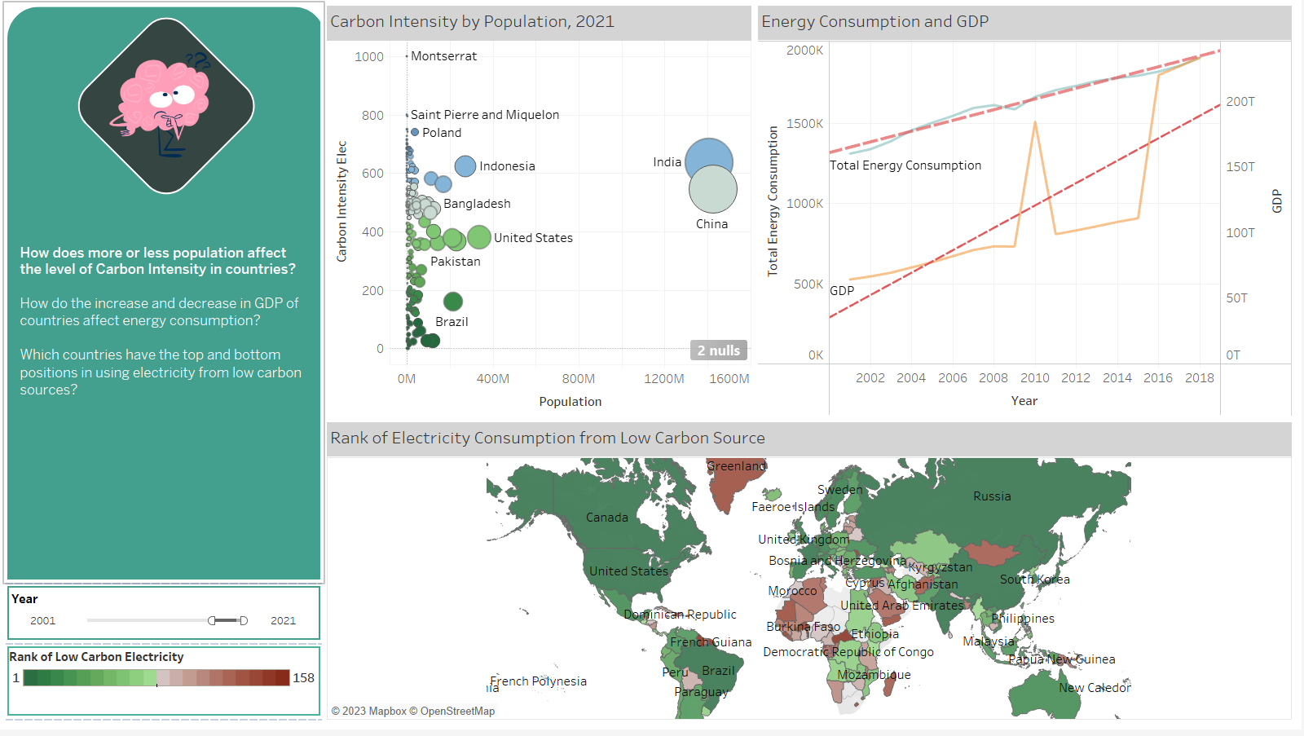

**Questions:**

* Is there a relationship between the population and the carbon intensity ?
* Is there a relationship between GDP and energy consumption?
* Which are the countries with the highest and the lowest consumption coming from low carbon sources?

**Analysis:**

The results of the analysis do not provide conclusive evidence of a relationship between population size and electricity consumption from low carbon sources. Several countries with low populations exhibit high consumption levels, indicating a lack of correlation. However, Brazil, India, and China stand out as exceptions to this trend, as they demonstrate a proportional relationship between the two variables.

In terms of GDP and electricity consumption from low carbon sources, the data suggests that the gap between the two has been consistently reducing over the years. This can be attributed to the fact that the GDP of the world has grown at a steeper rate than the energy consumption, which is a positive trend.

As expected, the countries with the lowest consumption levels tend to have smaller populations, whereas those with the highest populations tend to have higher levels of consumption. In this regard, India and China, with populations of over 1.5 billion each, have the highest electricity consumption levels.

***Share of renewable and fossil energy sources in the total energy consumption***

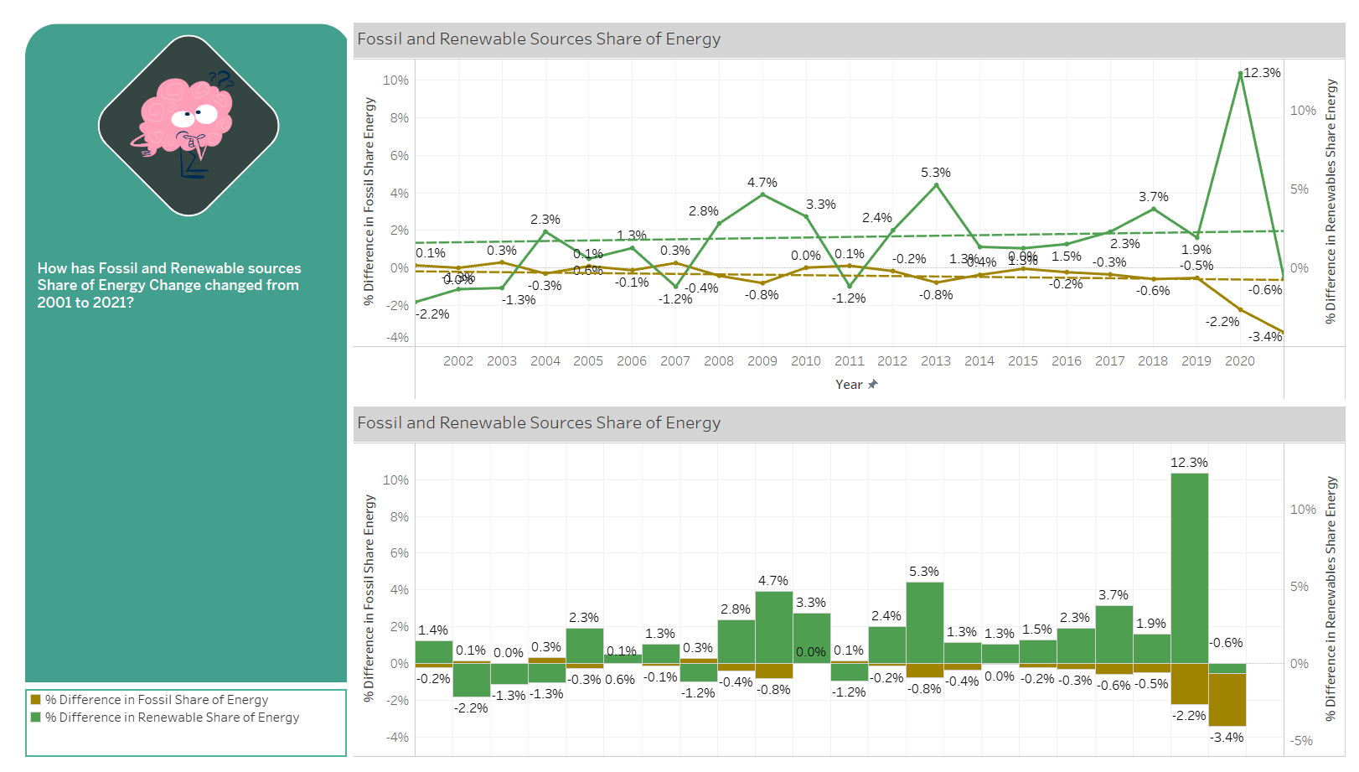

**Question:** How has the share of renewable and fossil energies change throughout the years?

**Analysis:**

The share of renewable energy sources has shown a steady increase over the years, indicating a positive outlook for the industry. This trend is evident from the chart, which illustrates the annual changes in the share of renewable energy sources since 2004. Notably, all the changes have been positive, providing conclusive evidence of the consistent growth of renewable energy sources for over fifteen years.

***Renewables generation over the years***

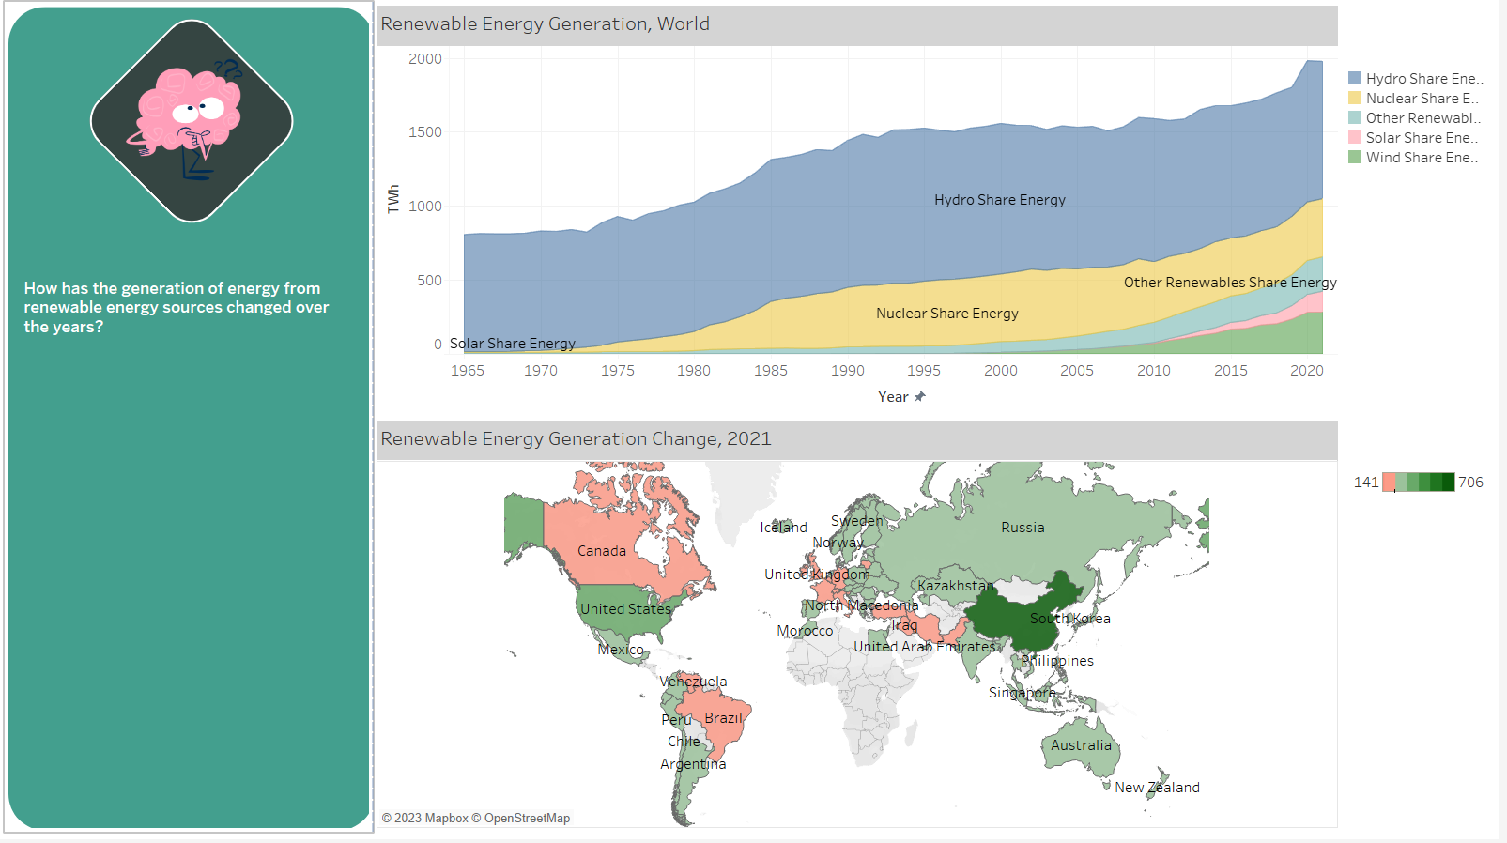

**Question:** How has the generation of renewable energy changed over the years?

# **Analysis:**

# The location of this screen within the workbook is significant as it builds on the information previously presented regarding countries with the highest energy consumption. Based on the data shown in this screen, it can be inferred that the countries with the highest energy consumption levels also demonstrate greater progress in terms of renewable energy consumption.

The top chart highlights that the proportion of hydro energy generation has remained relatively consistent over the years. In contrast, nuclear energy production exhibited the highest proportion between 1985 and 2010 before declining. As for the newer sources of renewable energy, such as wind and solar, their presence has marginally increased over the years, with a positive incremental trend in proportion to the total of renewable energy.

***Forecast for renewable energy sources***

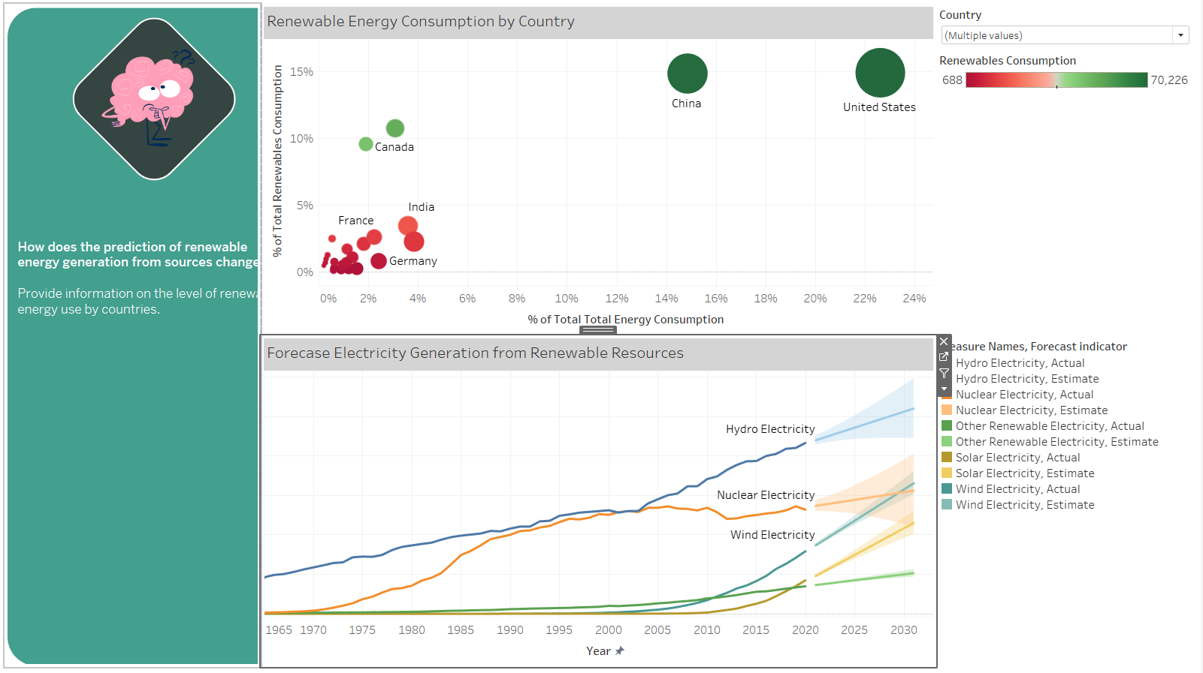

**Question:**  What is the forecast for renewable energy sources in the world?

**Analysis:** For all the types of renewable energy sources the forecast indicates that the presence of these will continue to grow. However, for nuclear energy, that between the year 1985 and 2010 had the steeper growth , there the possibility of presenting a decrease.

***Share of energy for renewable energy sources***

**Question:** how does the share of renewable energy sources compare for the countries with the gihest consumption of renewables ?

**Analysis:** Although some countries have made significant progress in adopting renewable energy sources, the proportion of renewable energy consumed is still relatively low, even in the most environmentally conscious nations, with an average of around 10-15% of total energy consumption. The accompanying map highlights that a significant portion of the world still relies heavily on fossil fuels for energy production, with little to no investment in clean energy consumption.

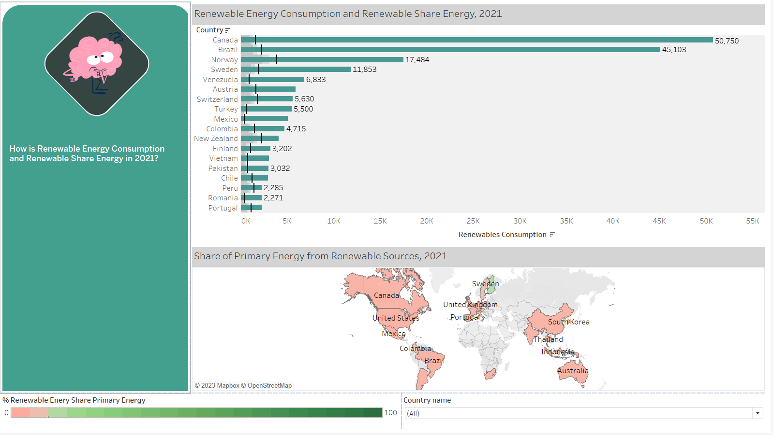

***Story***

This story features a series of interactive dashboards designed to guide the user through an educational journey on global energy consumption. Beginning with an initial analysis, the user is led through a progression of insights to uncover answers to their questions.

**Part B - POWER BI**

This part of the reports build in the previous charts from Tableau and continues to explores energy generation and consumption.

***Data Model***

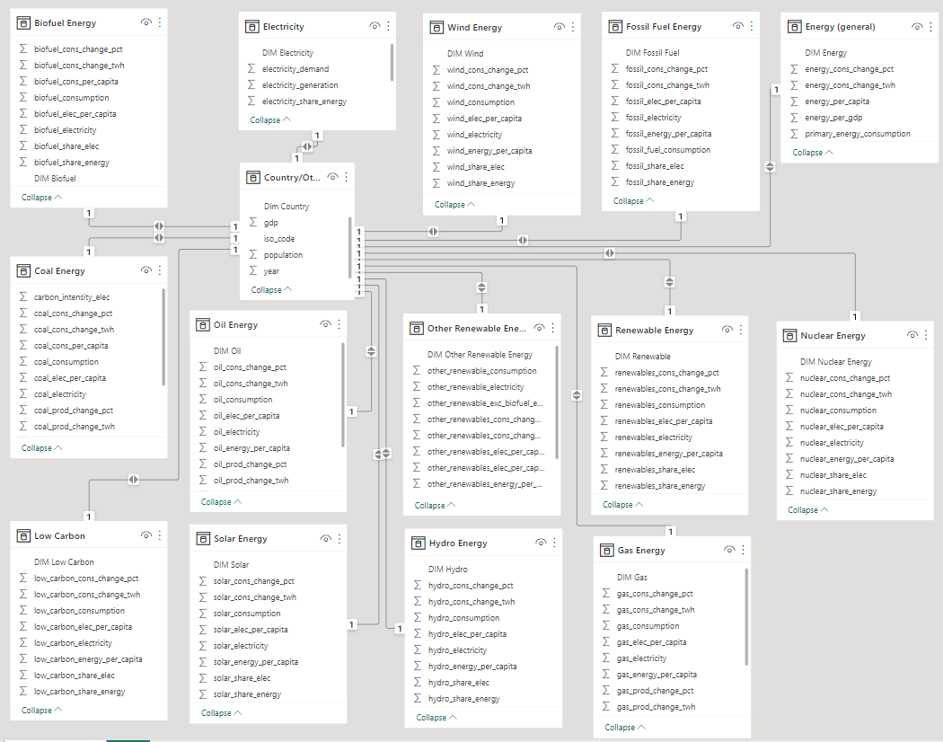

**Dashboard 1: Energy consumption, production, share energy by source, and greenhouse gas emission by Canada from 1992 to 2021.**

**Energy consumption by source and share of energy by source**

**Questions:**

• What energy source is used the most in Canada?

• What proportion do these energy sources account for?

**Analysis:**

Canada's two most used energy sources are fossil fuel energy, accounting for 68%, and renewable energy, accounting for 31%. Oil and gas account for more than 56% of fossil fuels, and coal accounts for nearly 8%. Hydropower accounts for the most significant proportion in the group of renewable energy; nuclear energy also plays a vital role, almost as important as coal energy, with a rate of 6.7%.

**Fossil fuel energy consumption and energy production**

**Question:** How is fossil fuel consumption and fossil fuel production changed over the years?

**Analysis:**

The utilization of oil as an energy source has demonstrated relatively stable consumption patterns over the years, with limited fluctuations. However, oil energy production has shown a noteworthy increase since 2009. In contrast, the consumption and production of energy from coal exhibit a declining trend over time. The consumption of gas for power generation experienced an initial rise from 1992 to 2001, followed by a decline until 2010. Subsequently, gas consumption for energy production has steadily increased from 2010 to 2021.

**Questions:**

• How were energy consumption and Energy per capita change over the years?

• What effect does energy consumption have on greenhouse gas emissions?

**Analysis:**

In the majority of years, energy consumption in Canada has exhibited an upward trend when compared to the previous year, with notable exceptions observed in 2009 and 2020, where a sharp decline in energy consumption is evident. Moreover, Canada's per capita energy consumption level is consistently higher than that of other countries, and it generally increased from 1992 to 2007. However, a decline in per capita energy consumption is observed after 2008, particularly pronounced in 2009 and 2020.

The second chart illustrates that both fossil fuel and renewable energy consumption in Canada have increased over time. However, a positive trend is observed in terms of greenhouse gas emissions, which tend to decrease sharply. This reduction in emissions associated with energy consumption is a favorable development for developed countries like Canada, as it signifies efforts towards mitigating the impact of energy use on the environment.

**Dashboard 2**: **Electricity by source, electricity demand, and electricity generation, the shared electricity by source.**

**Electricity by source in 1992 and electricity by source in 2021.**

**Question:** How are the changes in electricity by source over the last 30 years?

**Analysis:** Hydro energy remains the primary energy source to produce electricity over the years, accounting for over 60%. Next, nuclear energy still accounts for the second largest proportion with 14%. Gas energy shows importance when increasing from less than 3% to 11.5%. Coal energy plummeted from 17% to 6%. In addition, wind energy is a new energy source that provides electricity and tends to increase.

**Electricity demand and electricity generation**

**Question:**

• How has electricity demand in Canada changed over the years?

• Does the electricity production meet the power requirements?

**Analysis:**

The annual fluctuations notwithstanding, there is a discernible upward trend in electricity demand in Canada. Notably, electricity generation in the country consistently surpasses domestic demand, indicating a surplus of energy resources for electricity production. Moreover, this gap between electricity generation and demand tends to widen over time. Consequently, Canada is in a favorable position to export excess power to the United States, which experiences a consistent deficit between electricity production and demand.

**Share Electricity by energy sources, Electricity per capita by sources**.

**Question:**

* How is share electricity by energy sources in last 30 years?
* How is electricity per capita by source over the years?

**Analysis:**

Using a combination of a Tree Map chart and a tooltip with an Area chart, it is evident that electricity consumption per capita in Canada has generally decreased over the years for all energy sources, except for gas energy. Despite an increase in overall electricity production, the declining electricity consumption per capita indicates that Canada's population is growing at a faster rate. However, it should be noted that Canada consistently maintains a higher level of electricity production than domestic consumption, indicating that the reduction in electricity per capita does not adversely affect Canadians' access to electricity.

Based on the insights obtained from the two dashboards, several conclusions can be drawn. Firstly, energy consumption in Canada tends to increase over time. Fossil fuels still account for a significant proportion of energy consumption, representing over 68% of the total. However, there is a positive trend towards increasing consumption of renewable energy, which is promising in terms of reducing pollution associated with dependence on fossil fuels.

Secondly, Canada has a considerable share of electricity generation and electricity production from various energy sources, which is advantageous for domestic electricity consumption as well as electricity exports.

Lastly, greenhouse gas emissions have significantly decreased over the years, indicating the effectiveness of policies aimed at reducing pollution. This is a positive development in the country's efforts towards mitigating climate change and addressing environmental concerns.

***Canada: energy consumption and household income***

**Question**:

* What is the relation between household income and energy consumption in the country?

**Analysis:**

In the context of Canadian provincial energy consumption, it is noteworthy that Ontario surpasses all other provinces, including Quebec, with a consumption rate nearly double that of the latter. The predominant source of energy in Ontario, Alberta, British Columbia, and Manitoba is natural gas, accounting for over 50% of their total energy consumption. Conversely, the usage of heating oil for energy is significantly low across all provinces, as indicated by the pie chart, with natural gas comprising 53.24% of the energy consumption.

The income distribution of energy consumption, as depicted in the pie chart, does not provide substantial insights. However, a more comprehensive understanding can be obtained through the treemap, which reveals that households with higher incomes consume greater amounts of energy, while those with incomes below $20,000 per year consume comparatively lower amounts.

Further investigation into the number of households per income bracket is also enlightening. In Canada, households in the two highest income brackets, with annual incomes above $100,000 CAD, account for nearly 15 million households, representing almost half of the total households. The funnel chart provides intriguing information, as it shows that the number of households in each income bracket corresponds to the proportion of energy consumption presented in the treemap. However, it cannot be concluded that there is a proportional relationship between income and energy consumption, as the consumption patterns of households appear to be similar regardless of income level.

***Canada: energy consumption by dwelling type***

**Question:**

* What is the contribution of each type of dwelling to the total energy consumption of the country?

**Analysis:**

In Canada, single-detached homes are the most prevalent type of dwelling, accounting for approximately 40% of all residential units. It is reasonable to expect that this type of dwelling would also account for the highest proportion of energy consumption in the country. However, it is noteworthy to observe that not only do single-detached homes constitute the largest portion of dwellings, but their proportion of energy consumption is also significantly higher, with a staggering 79.1%, more than double its share in total dwelling types.

In terms of provincial contributions to energy consumption, a notable trend is observed in British Columbia. While it has consistently ranked third in energy consumption among the provinces in other years, during the period from 2014 to 2017, British Columbia emerged as the province with the highest energy consumption, surpassing other provinces.

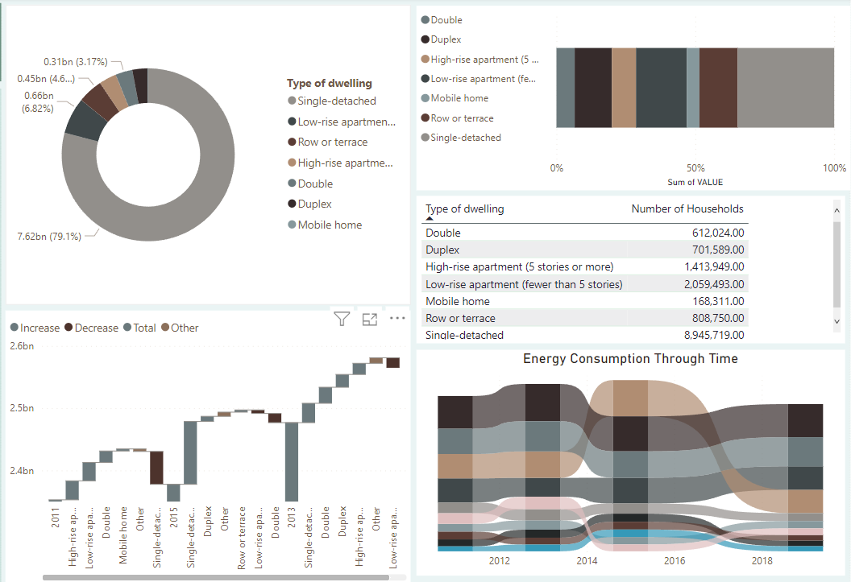

***GDP and CO2 emissions***

**Question:**

Are the wealthiest countries the ones that produce more CO2 emissions?

**Analysis:**

**Based on the analysis of the combined bar chart and table, it is evident that, with the exception of Kuwait and Qatar, countries with the highest per capita CO2 emissions do not necessarily correlate with their wealth or economic status. This observation suggests that these countries may have an unusually high rate of CO2 emission production relative to their economic prosperity.Chart
**

***CO2 emissions breakdown – Drill through detail by country***

**Questions:**

* What are the countries produce the most CO2?
* How many tons of CO2 are produced in the world per economic activity?

**Analysis:**

Based on the map view, it is evident that the countries with the highest CO2 emissions are the United States and China, which are also the two largest economies in the world. Notably, coal continues to be the primary source of CO2 emissions globally, accounting for almost as much emissions as the combined total of the other four categories. Interestingly, flaring, despite being the least contributing category, emerges as the second highest source of CO2 emissions, as it is closely tied to oil-related activities.

In the drill-through analysis for each country, the proportions of cumulative CO2 emissions and emissions for the last year are presented, providing insights into changes in fuel usage trends. Furthermore, the chart depicting the relationship between population change and CO2 production offers valuable information on the correlation between these two variables. While it is commonly expected that an increase in population would lead to higher CO2 emissions, a closer examination of China's data reveals that this is not always the case, suggesting complex dynamics at play in the relationship between population growth and CO2 emissions.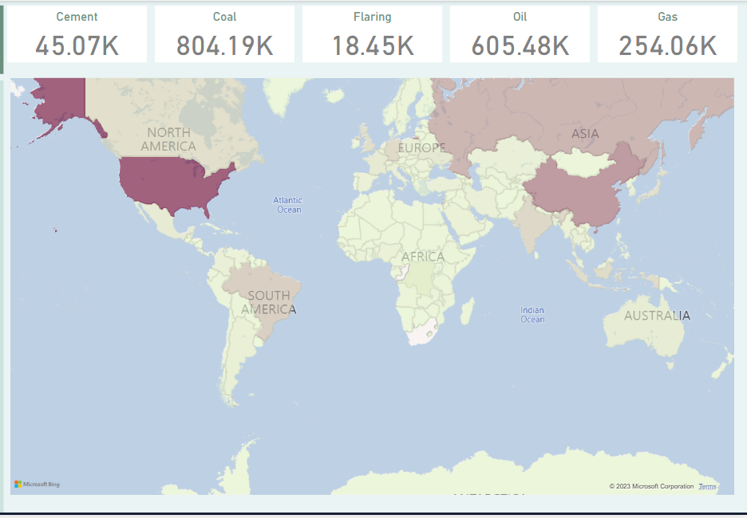

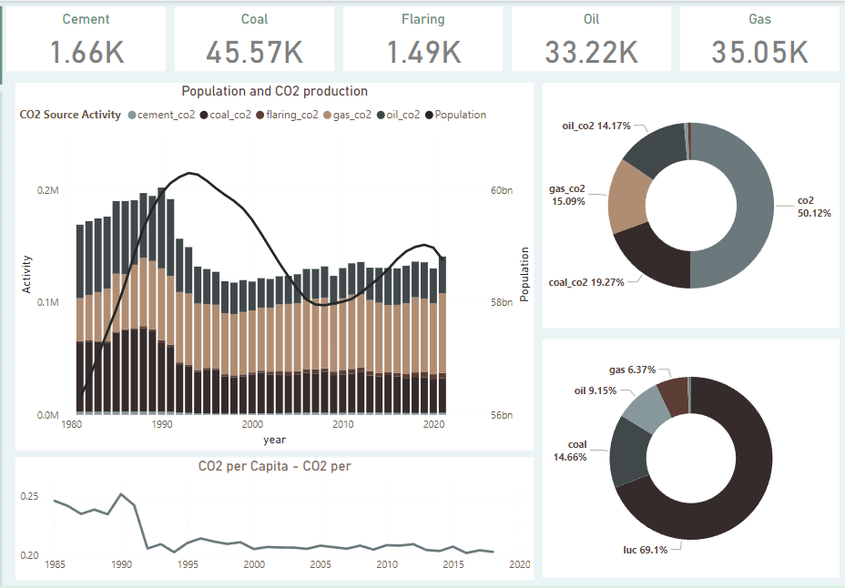

***Conclusion***

The use of sets, measure names, and values, color coding, calculated fields, and dashboard features are described. Some of the key findings include that most countries are meeting their electricity demands, there is a significant increase in electricity consumption from renewable resources in the last decade, and there is an upward trend in the share of renewable energy sources worldwide. The charts also reveal that countries with higher populations tend to have lower per capita consumption of renewable energy. Furthermore, the relation between GDP and the use of renewable energy is not consistent across all continents. For instance, Brazil and China have the highest consumption of renewables for their respective continents, while in Europe, the use of renewable energy is high despite the difference in GDP.

The visualizations demonstrate the potential for Tableau and Power BI to provide insights into renewable energy consumption and generation, and these tools can be utilized in future research. The use of predictive analytics can be further explored to forecast renewable energy generation worldwide. Additionally, the insights can be used to inform policy and investment decisions in renewable energy. For instance, countries with high populations that have lower per capita consumption of renewable energy can be targeted for investment in renewable energy infrastructure. Overall, the findings highlight the importance of sustainable energy practices and the potential for data visualization tools to aid in the transition to renewable energy.

***Future Work***

The visualizations presented in this work demonstrate some of the possible uses of Tableau and Power BI for analyzing and presenting data related to electricity demand and generation. However, there is still much potential for future work in this field. For example, exploring the impact of different policy decisions and changes in renewable energy technologies could be a valuable area of research. Another area of investigation could be a comparative analysis of different regions, examining the factors that contribute to variations in electricity demand and generation. Additionally, the integration of machine learning and artificial intelligence algorithms could improve the accuracy of future energy demand forecasts. Overall, these tools provide a powerful means of exploring and communicating complex data related to electricity demand and generation, and there is much room for future research and innovation in this area.

***Final Note***

The visualizations provided in the dashboards have effectively addressed the specific inquiries posed in each dashboard. Nevertheless, it should be noted that the scope of this topic is extensive, and in order to conduct a comprehensive energy analysis and CO2 emission analysis, additional data would be necessary, such as country-level energy consumption data disaggregated by demographic groups, economic activities, and other relevant factors.